Excel Assignment – 7

1. Using Insert Function, give examples of any function available in the

Different dropdowns present in the function library. For example

AutoSum, Recently Used, Text, Date & Time, etc.

2. What are the different ways you can select columns and rows?

3. What is AutoFit and why do we use it?

4. How can you insert new rows and columns into the existing table?

5. How do you hide and unhide columns in excel?

6. Create an appropriate table within the worksheet and use different

Functions available in the AutoSum command

1. The following Table depicts the use of five different function on a random samples of 1

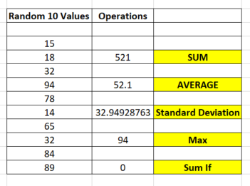

1. The Following are the different ways through which you can select columns of rows in Microsoft Excel

* By selecting the Letter at the top to select the entire column
* By clicking Space + Ctrl by selecting a single cell
* By selecting the row number
* By using Shift + Space by clicking a cell
* By using Ctrl + Shift + Right or Left Arrow

1. AutoFit is a feature in Excel that allows you to quickly adjust the row height or column width to fit the text completely
2. Click where you want in your table to add a row or column and then click the Layout tab. **To add rows, click Insert Above or Insert Below and to add columns, click Insert Left or Insert Right**.
3. Follow The Following steps to Hide, Un Hide Columns in Excel

* From the Home Tab in the cells group select format
* Under Visibility select Hide or Unhide
* Then Click on Unhide rows or Unhide Columns as per desired requirements.

1. The Following Picture shows the use of 3 different functions on a random sample of 10 numbers

